

**Discovering Knowledge**

**COURSE: CSL 220**

**DATABASE MANAGEMENT SYSTEM**

**PROJECT REPORT**

**CLASS: BSE – 4A (SPRING - 2024)**

**Finance Management System**

**Group Members**

|  |  |
| --- | --- |
| **Student Name** | **Enrollment#** |
| Syed Fahad Ali Gillani | 02-131222-083 |

**Submitted to:**

Course Instructor: Engr. Bushra Fazal

Lab Instructor: Engr. Noor us Sabah

**Department of Software Engineering**

**BAHRIA UNIVERSITY KARACHI CAMPUS**

**Abstract**

The Financial Management System is a comprehensive software solution designed to empower individuals and organizations with effective financial planning and management capabilities. This project aims to develop a user-friendly platform that enables users to track their income, expenses, budgets, savings goals, debts, investments, and assets in one centralized database. Through features such as transaction tracking, budget management, goal setting, and notification alerts, users can gain insights into their financial health, make informed decisions, and work towards achieving their financial objectives. With a focus on data integrity, security, and user experience, the Financial Management System aims to provide a reliable and efficient tool for managing personal and business finances.

TABLE OF Contents

➢ Introduction 4

➢ Problem Statement 4

➢ Proposed Solution 4

1. Features of the project 4

2. Methodology 5

3. Technologies 5

4. Block Diagram 5

5. Technologies to be used 6

➢ Software Design Description 6

1. Design Overview 6

2. Work Flow Diagram 6

3. Use Case Diagram 7

4. Sequence Diagram 7

5. ER Diagram 8

6. Technologies 8

7. Block Diagram 9

8. Technologies to be used 9

➢ Project Scope 9

➢ Module Distribution 10

➢ Code 10

➢ Interfaces 15

➢ Conclusion 16

➢ References 16

# Introduction

In today's world, managing money can be tricky with so many things to keep track of. That's why we're working on a Financial Management System (FMS) project. The FMS is like a digital helper that makes it easier for people and businesses to handle their money smartly. It does things like keeping tabs on where money is going, setting budgets, reaching savings goals, and showing how well everything is going financially. Our project idea came from seeing how complex money matters can be nowadays and the need for tools that anyone can use to manage money better.

# Problem Statement

In today's dynamic financial environment, individuals and organizations struggle to manage finances effectively due to complexity and lack of automation. Traditional methods fall short in organizing and tracking income, expenses, and investments, leading to a need for a user-friendly Financial Management System. This system should centralize data, offer real-time insights, and enable informed decision-making to improve financial health and achieve goals.

# Proposed Solution

## Features of the project

* User Authentication
* Income and Expense Tracking
* Budget Management
* Goal Setting and Tracking
* Reminders and Notifications
* Income Source Management
* Expense Frequency Management
* Recurring Expenses Management
* Payment Method Management
* Savings Goal Progress Tracking
* Debt Management
* Investment Management
* Asset Management

## Methodology

The methodology for implementing the Financial Management System project in SQL Server Management Studio (SSMS) involves several key steps. First, I will conduct a thorough analysis of the project requirements, identifying the functionalities needed for user authentication, transaction tracking, budget management, goal setting, and notification handling. Next, I will design the database schema, creating tables to store user information, financial transactions, budget data, goals, notifications, and other relevant entities. I will establish relationships between these tables using primary and foreign keys to ensure data integrity. Once the database schema is finalized, I will proceed with creating the database in SSMS and populating it with sample data for testing purposes. Then, I will develop SQL scripts to implement CRUD (Create, Read, Update, Delete) operations for managing user data, financial transactions, budgets, goals, and notifications. Throughout the development process, I will adhere to best practices for SQL query optimization, error handling, and security to ensure the reliability and efficiency of the Financial Management System. Finally, I will conduct thorough testing to validate the functionality and performance of the system, making any necessary adjustments or refinements before final deployment.

## Technologies

* SQL
* SQL SERVER MANAGEMENT STUDIO
* C#
* VISUAL STUDIO
* Guna Ui Framework

## Block Diagram

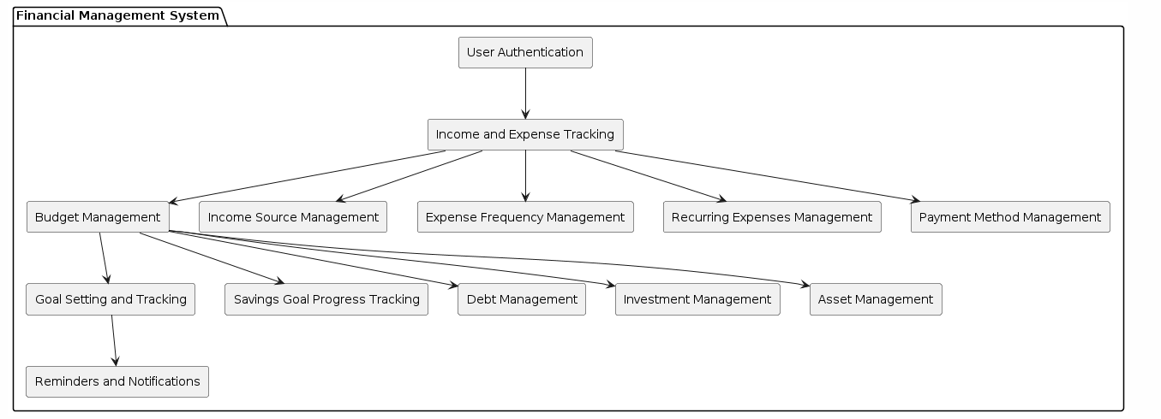

## Technologies to be used

* SQL
* SQL SERVER MANAGEMENT STUDIO
* C#
* VISUAL STUDIO
* Guna Ui Framework

# Software Design Description

## Design Overview

The Finance Management System is designed with a robust SQL database and a user-friendly C# Windows Forms application. The SQL database in SSMS consists of 15 structured tables, including User, Transaction, Budget, and Investment, ensuring comprehensive financial data management. CRUD operations, stored procedures, and triggers are implemented for efficient data manipulation and business rule enforcement. The C# Windows Forms application provides a seamless interface for users to perform CRUD operations on the database, featuring data binding, input validation, and robust error handling. This design ensures a reliable, secure, and intuitive platform for effective financial management.

## Work Flow Diagram

## Use Case Diagram

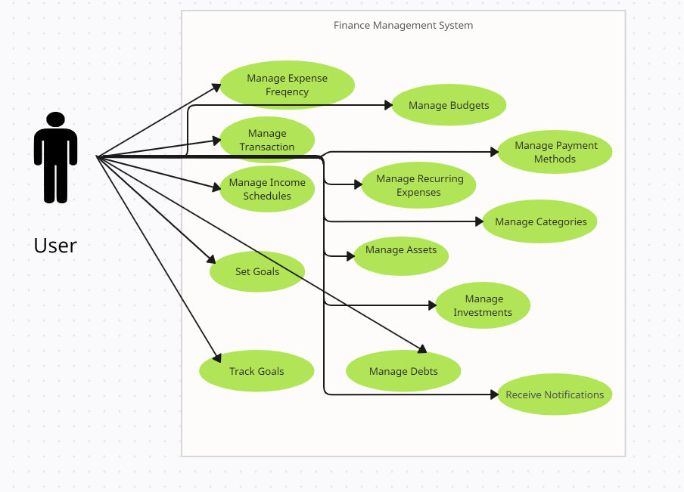

## Sequence Diagram

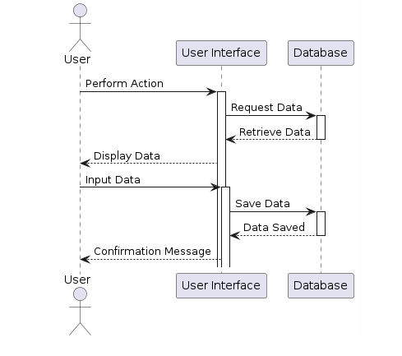

## ER Diagram

## Technologies

* SQL
* SQL SERVER MANAGEMENT STUDIO
* C#
* VISUAL STUDIO
* Guna Ui Framework

## Block Diagram



## Technologies to be used

* SQL
* SQL SERVER MANAGEMENT STUDIO
* C#
* VISUAL STUDIO
* Guna Ui Framework

# Project Scope

The scope of the Finance Management System project encompasses the development of a comprehensive software application aimed at assisting individuals and organizations in managing their finances effectively. The project will involve the creation of a relational database model with tables including User, Transaction, Category, Budget, Goal, Notification, Income Source, Expense Frequency, Recurring Expenses, Payment Method, Income Schedule, Savings Goal Progress, Debt, Investment, and Asset.

Tables:

1. User
2. Transaction
3. Category
4. Budget
5. Goal
6. Notification
7. Income Source
8. Expense Frequency
9. Recurring Expenses
10. Payment Method
11. Income Schedule
12. Savings Goal Progress
13. Debt
14. Investment
15. Asset

# Module Distribution

To build the Finance Management System project, I first designed and implemented a comprehensive SQL database in SQL Server Management Studio (SSMS), creating 15 well-structured tables to store various financial data. I then developed stored procedures, triggers, and CRUD queries to manage data efficiently and enforce business rules. With the database foundation in place, I proceeded to develop a C# Windows Forms application, focusing on one table to demonstrate CRUD operations. This involved designing a user-friendly interface with data binding and input validation, implementing the necessary code for database interactions, and incorporating error handling and security measures to ensure robust and secure application performance.

# Code

**Front.cs**

using System;

using System.Collections.Generic;

using System.ComponentModel;

using System.Data;

using System.Drawing;

using System.Linq;

using System.Text;

using System.Threading.Tasks;

using System.Windows.Forms;

using System.Data.SqlClient;

namespace DBPROJ

{

public partial class front : Form

{

public front()

{

InitializeComponent();

}

private void Exit_Click(object sender, EventArgs e)

{

this.Close();

}

private void Cont_Click(object sender, EventArgs e)

{

Data d = new Data();

this.Hide();

d.Show();

}

}

}

**Del.cs**

using System;

using System.Collections.Generic;

using System.ComponentModel;

using System.Data;

using System.Data.SqlClient;

using System.Drawing;

using System.Linq;

using System.Security.Cryptography;

using System.Text;

using System.Threading.Tasks;

using System.Windows.Forms;

using System.Xml.Linq;

namespace DBPROJ

{

public partial class Del : Form

{

SqlConnection conn;

DataTable dt;

public Del()

{

InitializeComponent();

conn = new SqlConnection("Data Source=localhost\\SQLEXPRESS02;Initial Catalog=dummy;Integrated Security=True;");

conn.Open();

dt = new DataTable();

ComboBox();

}

private void cross_Click(object sender, EventArgs e)

{

this.Hide();

Data f = new Data();

f.Show();

}

private void ComboBox()

{

using (SqlCommand command = new SqlCommand("select AssetID from Asset", conn))

{

SqlDataReader reader = command.ExecuteReader();

cbasset.Items.Clear();

while (reader.Read())

{

cbasset.Items.Add(reader["AssetID"].ToString());

}

conn.Close();

}

}

private void guna2GradientButton1_Click(object sender, EventArgs e)

{

int aid;

try

{

if (cbasset.Text == "")

{

MessageBox.Show("select AssetID");

}

else

{

aid = int.Parse(cbasset.Text);

SqlDataAdapter da = new SqlDataAdapter("exec DeleteAsset @AssetID='" + aid+"'", conn);

da.Fill(dt);

MessageBox.Show("Record Deleted Successfully!");

this.Hide();

}

}

catch (Exception ex)

{

MessageBox.Show("Error!");

}

}

private void cbuser_SelectedIndexChanged(object sender, EventArgs e)

{

}

private void Del_Load(object sender, EventArgs e)

{

}

}

}

**Data.cs**

using System;

using System.Collections.Generic;

using System.ComponentModel;

using System.Data;

using System.Drawing;

using System.Linq;

using System.Text;

using System.Threading.Tasks;

using System.Windows.Forms;

using System.Data.SqlClient;

using System.Data;

using System.DirectoryServices.ActiveDirectory;

using System.Collections;

namespace DBPROJ

{

public partial class Data : Form

{

SqlConnection conn;

DataTable dt;

string name, dsc;

int aid, uid, val;

public Data()

{

InitializeComponent();

conn = new SqlConnection("Data Source=localhost\\SQLEXPRESS02;Initial Catalog=dummy;Integrated Security=True;");

conn.Open();

dt = new DataTable();

ComboBox();

GRID();

}

private void cross_Click(object sender, EventArgs e)

{

this.Hide();

front f = new front();

f.Show();

}

private void save_Click(object sender, EventArgs e)

{

try

{

if (tval.Text == "" || tid.Text == "" || cbuser.Text == "" || tname.Text == "" || tdesc.Text == "")

{

MessageBox.Show("Fill all Fields!");

}

else

{

val = int.Parse(tval.Text);

aid = int.Parse(tid.Text);

uid = int.Parse(cbuser.Text);

name = tname.Text;

dsc = tdesc.Text;

SqlDataAdapter da = new SqlDataAdapter("exec CreateAsset @AssetID='" + aid + "', @UserID='" + uid + "', @AssetName='" + name + "', @Description='" + dsc + "', @EstimatedValue='" + val + "'", conn);

da.Fill(dt);

MessageBox.Show("Data Inserted Successfully!");

}

}

catch (Exception ex)

{

MessageBox.Show("Error!");

}

}

private void GRID()

{

string query = "Select * from Asset";

SqlDataAdapter sd = new SqlDataAdapter(query, conn);

sd.Fill(dt);

grid.DataSource = dt;

}

private void ComboBox()

{

using (SqlCommand command = new SqlCommand("select UserID from us", conn))

{

SqlDataReader reader = command.ExecuteReader();

cbuser.Items.Clear();

while (reader.Read())

{

cbuser.Items.Add(reader["UserID"].ToString());

}

conn.Close();

}

}

private void update_Click(object sender, EventArgs e)

{

try

{

if (tval.Text == "" || tid.Text == "" || cbuser.Text == "" || tname.Text == "" || tdesc.Text == "")

{

MessageBox.Show("Fill all Fields!");

}

else

{

val = int.Parse(tval.Text);

aid = int.Parse(tid.Text);

uid = int.Parse(cbuser.Text);

name = tname.Text;

dsc = tdesc.Text;

// Check if asset ID exists

SqlCommand checkCmd = new SqlCommand("SELECT COUNT(*) FROM Asset WHERE AssetID = @AssetID", conn);

checkCmd.Parameters.AddWithValue("@AssetID", aid);

conn.Open();

int assetCount = (int)checkCmd.ExecuteScalar();

conn.Close();

if (assetCount > 0)

{

// Update asset details

SqlCommand updateCmd = new SqlCommand("UPDATE Asset SET UserID = @UserID, AssetName = @AssetName, Description = @Description, EstimatedValue = @EstimatedValue WHERE AssetID = @AssetID", conn);

updateCmd.Parameters.AddWithValue("@AssetID", aid);

updateCmd.Parameters.AddWithValue("@UserID", uid);

updateCmd.Parameters.AddWithValue("@AssetName", name);

updateCmd.Parameters.AddWithValue("@Description", dsc);

updateCmd.Parameters.AddWithValue("@EstimatedValue", val);

conn.Open();

updateCmd.ExecuteNonQuery();

conn.Close();

MessageBox.Show("Data Updated Successfully!");

}

else

{

MessageBox.Show("Asset ID not found!");

}

}

}

catch (Exception ex)

{

MessageBox.Show("Error!");

}

}

private void del_Click(object sender, EventArgs e)

{

Del d = new Del();

d.Show();

}

private void refresh_Click(object sender, EventArgs e)

{

this.Hide();

Data f = new Data();

f.Show();

}

}

}

# Interfaces

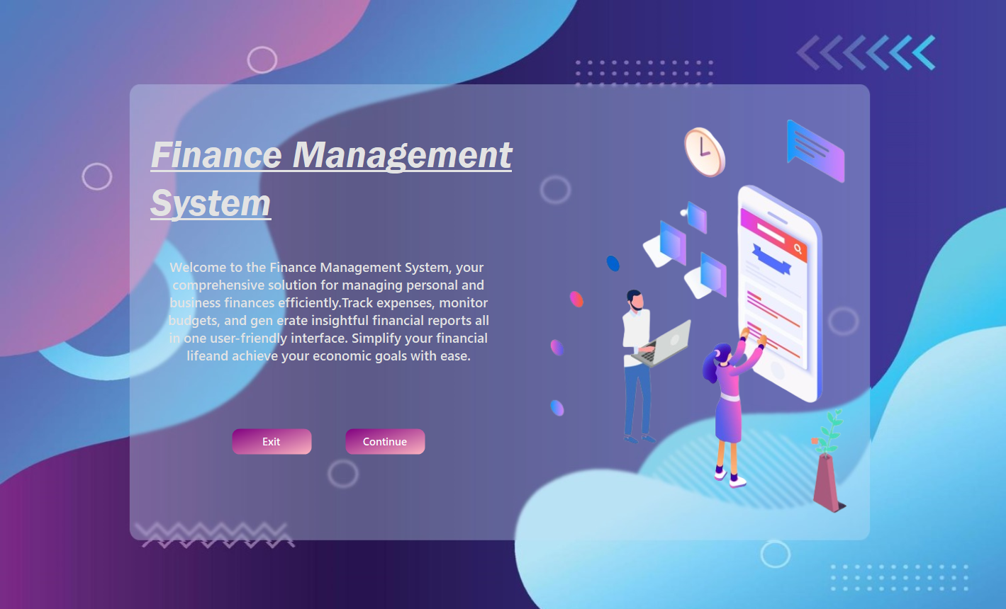

**Home Page**

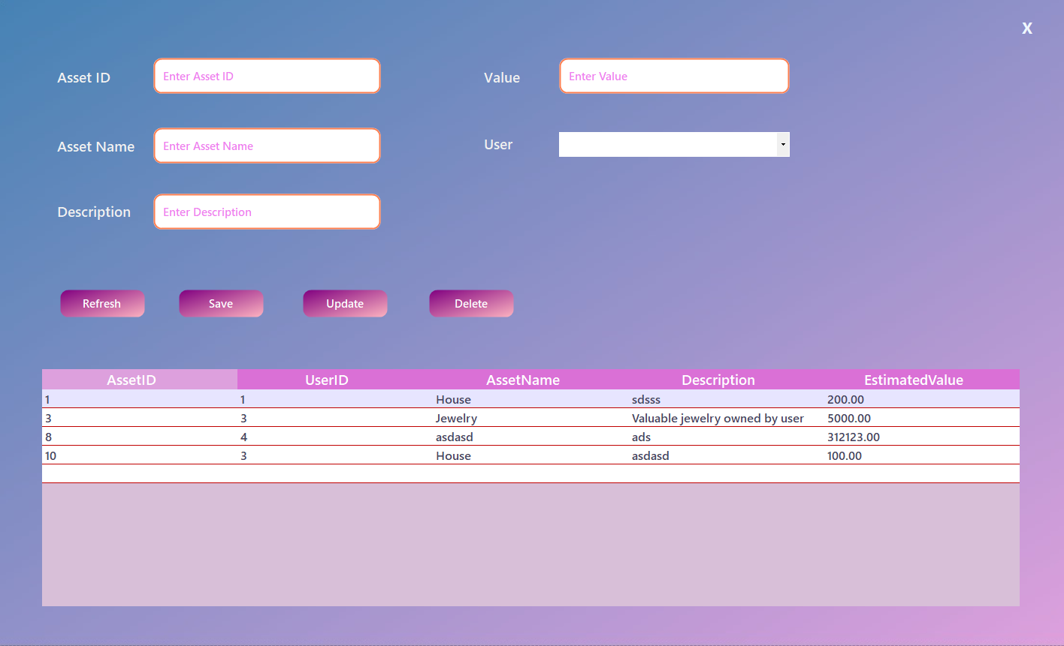

**Data Entry Page**

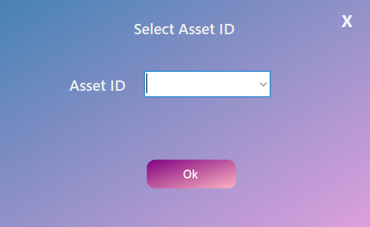

**Delete Request Box**

# Conclusion

The Finance Management System project delivers a comprehensive and user-friendly tool for managing personal and organizational finances. By developing a robust SQL database with 15 tables and integrating it with a C# Windows Forms application, the project ensures efficient data handling and security. Key features such as transaction tracking, budget management, and goal setting provide users with valuable insights and help them make informed financial decisions. The successful implementation of CRUD operations and procedures ensures data accuracy and reliability, making the system an effective solution for financial planning and management.

# References

<https://www.sap.com/mena/products/erp/s4hana/what-is-financial-management-system.html>

<https://www.oracle.com/pk/erp/financials/what-is-financial-management-system/>